# Overview

*Query > Search Definition > ElasticSearch > Kibana Visualisation & Dashboard > PeopleSoft Tile*

## Query and Search Definition

1. Create a QueryRequires a Drilling URL, and a Last Updated Date Time field.
2. Define Search DefinitionUses the Query  
   Can belong to multiple Search Categories.
3. Define Search CategoryCan have multiple Search Definitions

## ElasticSearch Indexing

1. Deploy Search Objects  
   Prepares the Search Definition for indexing by Elasticsearch.
2. Schedule Search Indexes  
   Runs ElasticSearch’s indexing of deployed Search Definitions.

## Global Search

*This step is optional and is not required for Kibana.*

1. Define Search ContextsAdd Search Categories to Global Search
2. Permission Lists  
   Add Search Group/Category to a Permission List
3. Verify Global SearchTest your Search Definition using Global Search

## Kibana

1. Kibana ServerNavigate to the Kibana server
2. Index Pattern  
   Import the ElasticSearch index to use in visualisations
3. Visualisations  
   The fun part
4. Dashboard  
   Combine multiple visualisations into a dashboard
5. Filters  
   A word on how Kibana filters work and affect all visualisations in a dashboard real-time.

## PeopleSoft Kibana Dashboard

1. Import Kibana Dashboard
2. Configure Kibana Dashboard  
   A wizard to create a homepage tile from an imported Kibana dashboard.
3. Deploy Kibana Dashboard
4. Add Tile to Homepage

# Common Navigations

*Reporting Tools > Query > Query Manager*

*Reporting Tools > Kibana*

*PeopleTools > Search Framework > Designer > \**

*PeopleTools > Search Framework > Administration > \**

# PeopleSoft

## Query

*Reporting Tools > Query > Query Manager*

The Query must include:

* LASTUPDDTTM (this could be derived)  
  and criteria against it (just the default prompt)
* A Drilling URL

LASTUPDTTM is required by ElasticSearch to index the data. All indexes in ElasticSearch are by *time*, which is what it was originally built for. It’s a little search engine.

Drilling URLs are a type of Query Expression.

**Note**: If your Record does not have LASTUPDTTM you could (I think) add it as an Expression, and hard-code it to 1900-01-01.

**Tip**: When running your Query, the format for LASTUPDDTTM is the same as the clock in the   
bottom-right corner of your screen. “25/12/2020 01:00am” for example.

### Example

*I’d like to see a visualisation of how Departments’ locations, and how many active Employees are in each Department Location, be able to click on an Employee to see their Job Data.*

I’ve created a Query called MN_JOB_LOCATION:

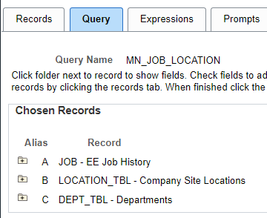

Basic stuff: It has Joins to LOCATION_TBL and DEPT_TBL to get their DESCR fields, effective date logic etc. etc. Nothing fancy.

**Note**: we have a Prompt on JOB.LASTUPDDTTM, not less than *date*. **This is required.**

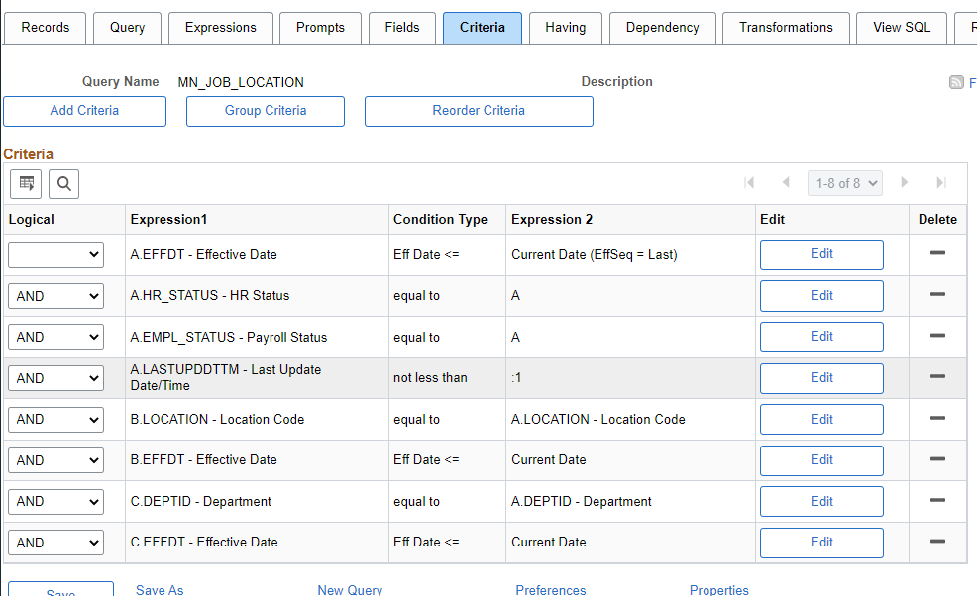

Next, I’ve added an Expression, of type ‘Drilling URL’ and ‘Component URL’. This will allow us to click on and Employee in the Kibana Visualisation to open their Job Data.

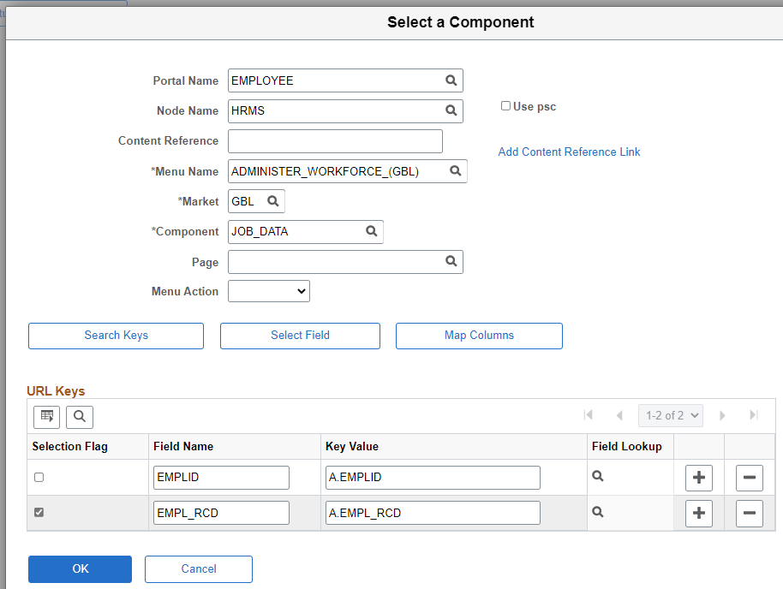

Which creates the URL string:

'psp/EMPLOYEE/HRMS/c/ADMINISTER_WORKFORCE_(GBL).JOB_DATA.GBL  
?&EMPLID=%A.EMPLID%&EMPL_RCD=%A.EMPL_RCD%'

The Fields:

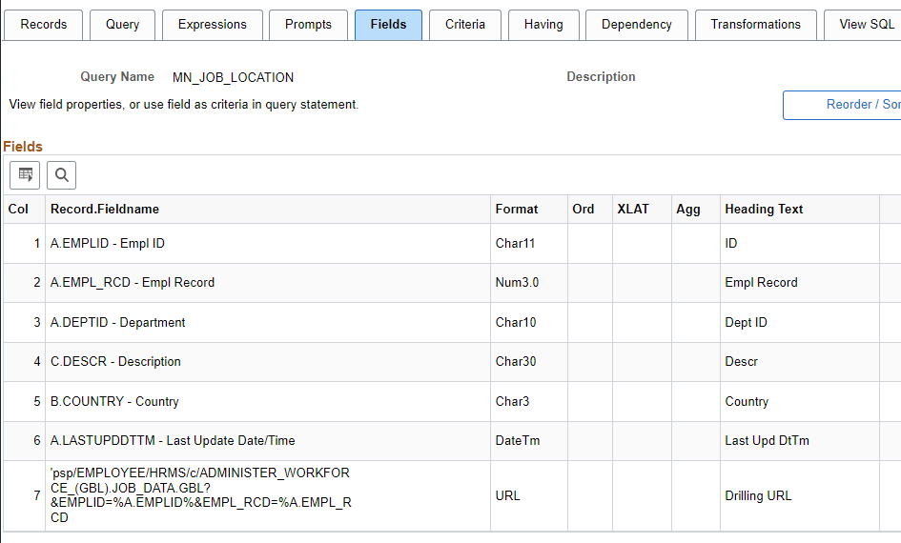

When we run the Query, we can use the Last Updated Date Time parameter in *the same format as the clock at bottom-right of your screen:*

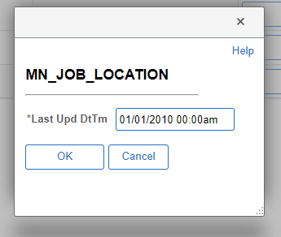

Which returns data:

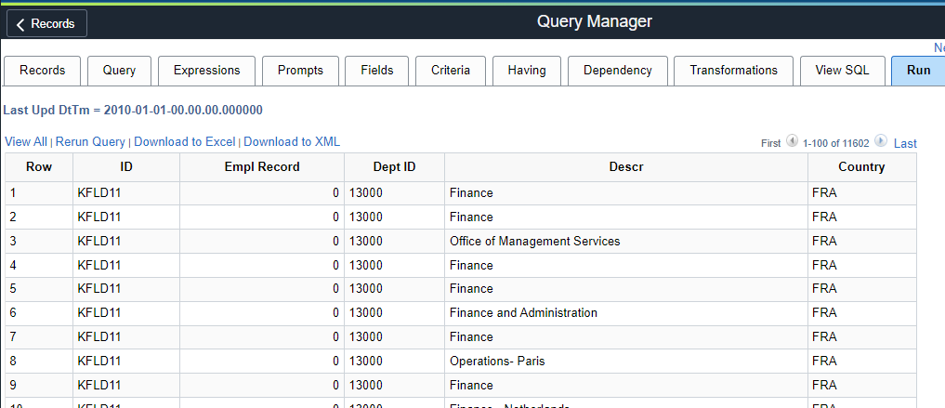

## Define Search Definition

*PeopleTools > Search Framework > Designer > Define Search Definitions*

**Note:** that everything else we do in PeopleSoft from herein will be under the *Search Framework* navigation path. The *Designer* and *Administration* folders.

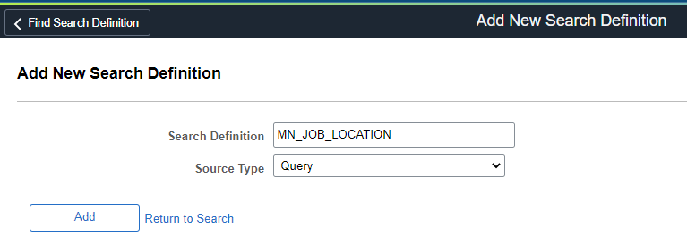

### General Settings

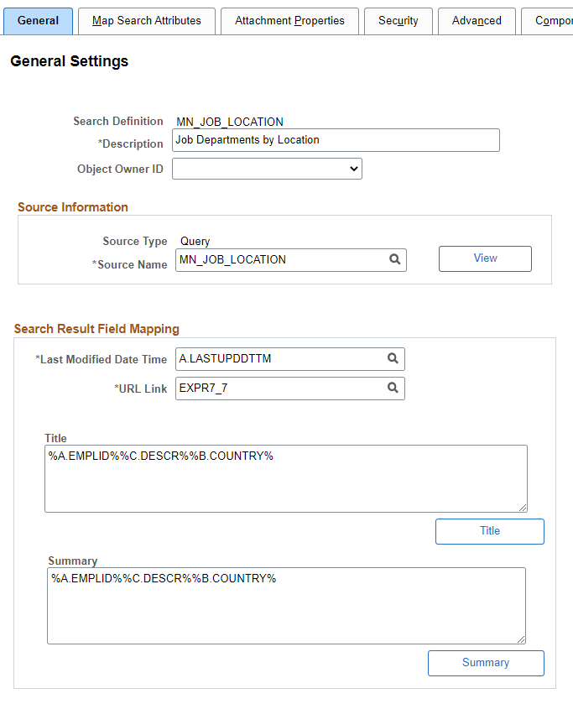

### Search Attribute Mapping

We only want to search on Department ID, Department Description, and Country. (I think)

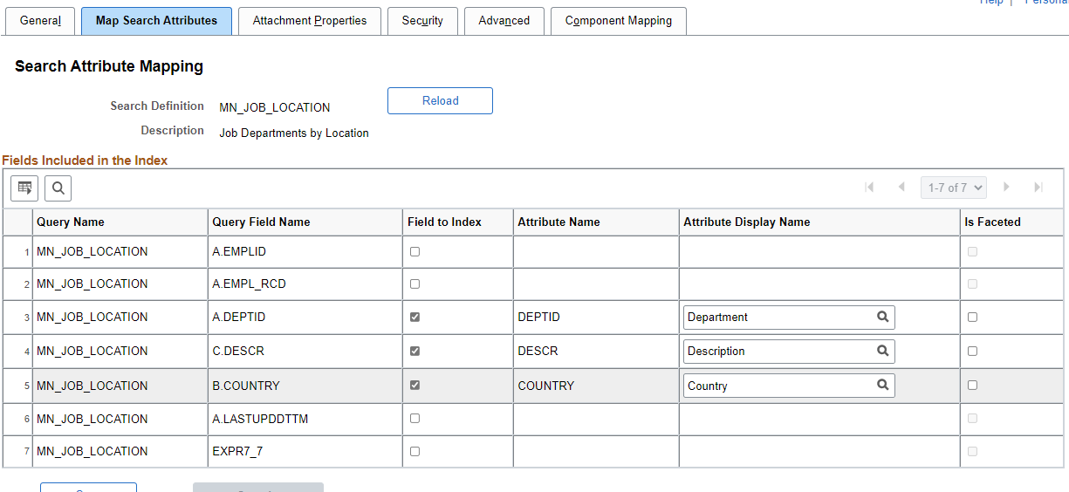

### Security

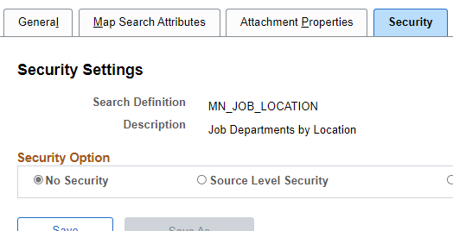

**Attachment Properties**, **Advanced**, and **Component Mapping** tabs I have left as-is.  
We have no attachments, nothing advanced, and our Drilling URL handles the Component Mapping (I think).

## Define Search Category

*PeopleTools > Search Framework > Designer > Define Search Category*

*“Yo, what* ***is*** *a Search Category?”*

In Global Search you will notice a list of existing Search Categories, like ‘Absence Balance’,   
‘Company Directory’, etc.

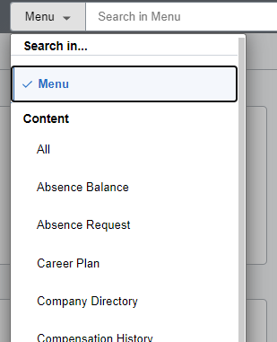

**Note**: We can always add a Search Definition to an existing Search Category

Our new, example Search Category:

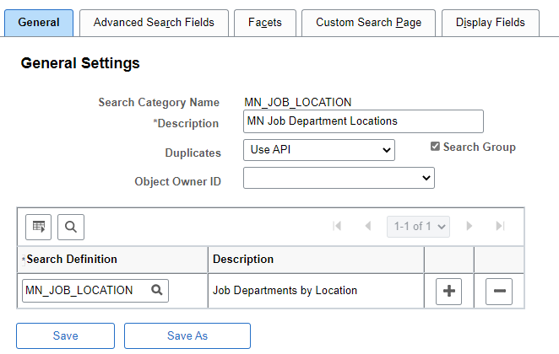

Selecting ‘Search Group’ adds this to *Global Search*

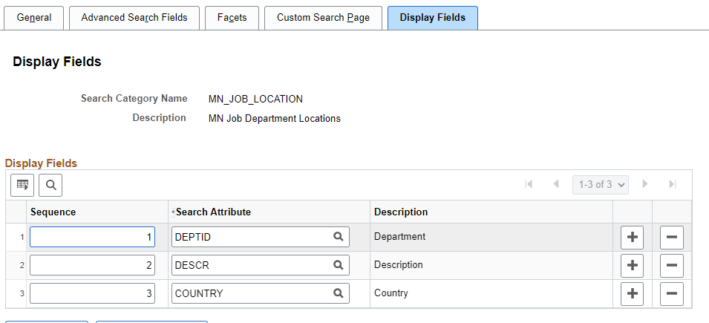

Note that ‘Advanced Search Fields’ will auto-populate.

Save. That’s it.

## Deploy Search Objects

*PeopleTools > Search Framework > Designer > Define Search Category*



Select it, and click ‘Deploy’.



## Schedule Search Indexes

*PeopleTools > Search Framework > Designer > Define Search Category*

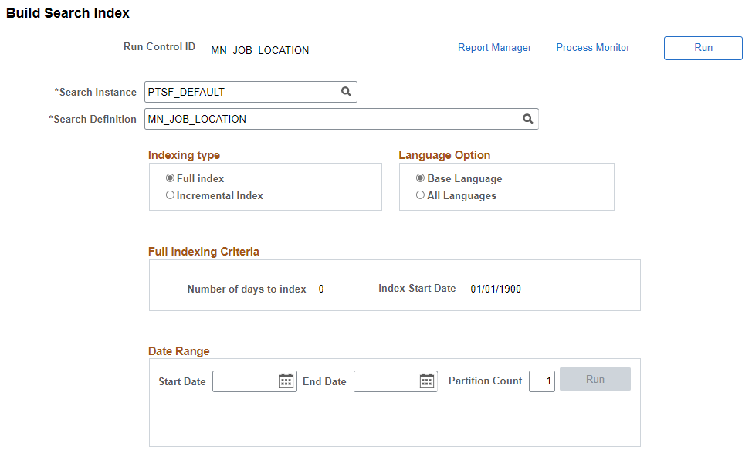

**Note** the Indexing Type = ‘Full Index”

**Note** The 2nd ‘Run’ at bottom requires start and end dates, if using. Just use ‘Run’ at top (bad UI)

**Note** If you change a Search Definition’s Title/Summary, for example, you need to rerun the crawl/schedule the index again. No need to redeploy, however.

When the process completes you can go back to *Deploy Search Definition,* and you’ll see crawl is successful. Hurray.



Note: These, three step are optional; not required for Kibana!

## Define Search Contexts

*PeopleTools > Search Framework > Administration > Define Search Contexts*

This adds our Search Context to appear as part of **Global Search**

Add and Save:



## Permission Lists

*PeopleTools > Security > Permissions and Roles > Permission Lists*

I just added it to the “PTPT1000 / PeopleSoft User” Permission List for this example, but we may need to consider what the correct Permission List is, depending on content and target users, etc.

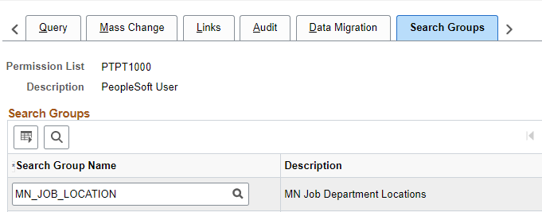

## Verify Global Search

*Global Search (top of every page)*

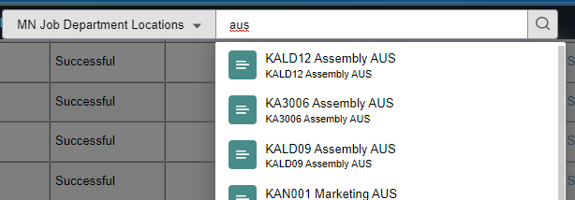

If you can’t see it, here is Oracle’s problem solver:  
[E-ES/SES: Search Category not Showing Up in Global Search Bar (Doc ID 1534166.1)](https://support.oracle.com/epmos/faces/DocContentDisplay?_afrLoop=354661868551259&id=1534166.1&_afrWindowMode=0&_adf.ctrl-state=flnrutv93_4)

# Kibana

*Reporting Tools > Kibana*

A PeopleSoft user with the ‘**Search Administrator’ Role**   
or a user who has edit privilege or create privilege for any dashboard   
can log on to Kibana directly.

The edit or create privilege is specified on the Kibana Privileges page.

## Kibana Server

If the Kibana server is down, then there will be an error that includes the server’s name.

Log onto this server and run kibana.bat, as the administrator (right-click).

D:\ELK\pt\Kibana7.10.0\bin\kibana.bat

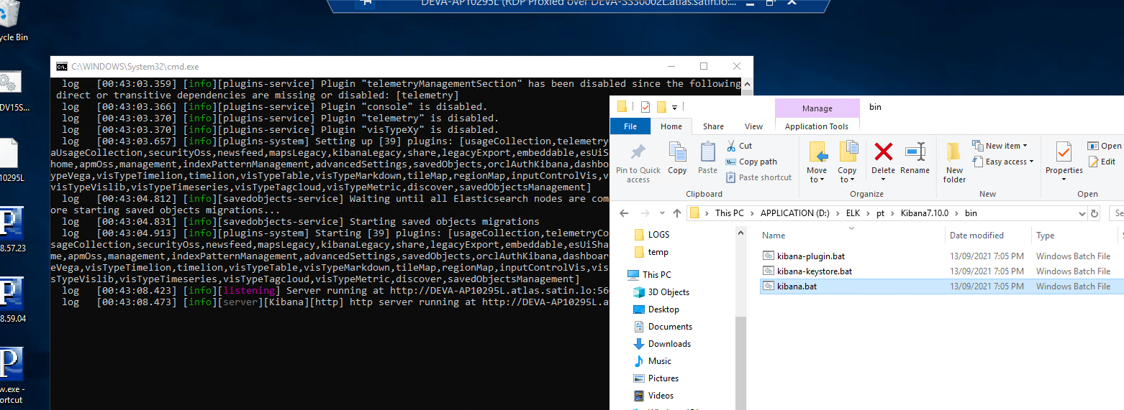

## Index Pattern

*Management > Stack Management > Index Patterns*

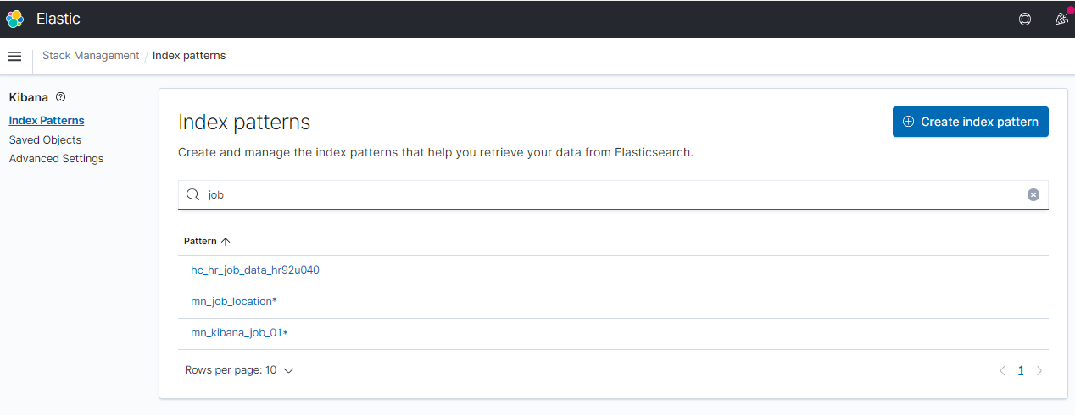

Search for your recently indexed ElasticSearch index, and then click ‘Create index pattern’.

Here is what our example looks like:

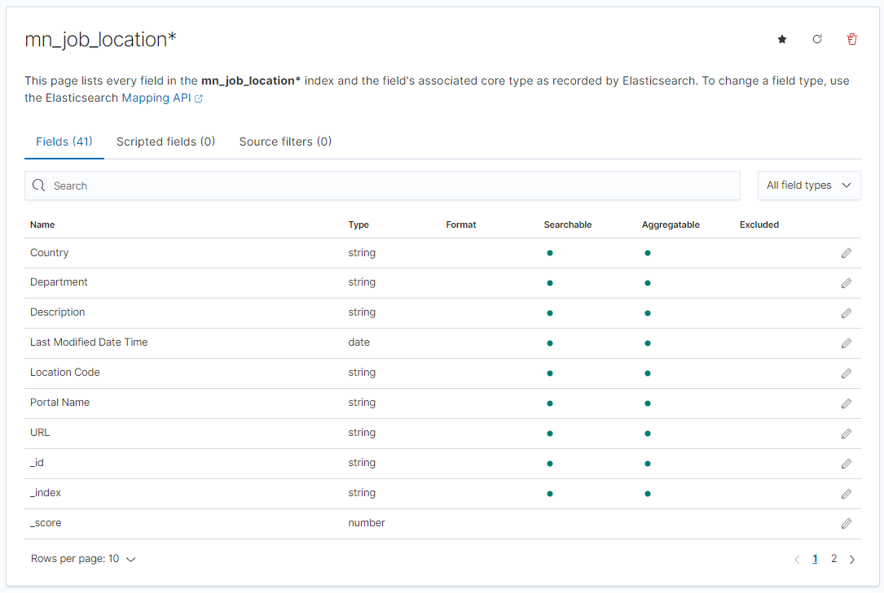

## Visualisations

*Kibana > Visualize*

Finally, the fun stuff! This document won’t go through every visualisation type. Have a play yourself. There are a few things that are common for all though.

### Visualisation Example 1

Click ‘Create visualisation’. I’ve opted to go with a Horizontal Bar.

I selected our mn_job_location index pattern:

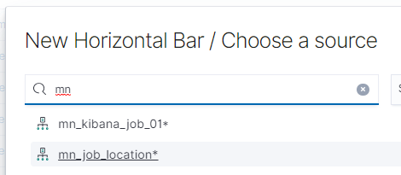

I’ve added a bucket, to split the series, by Country, ordered by count, and only showing the top 6 (the 6th being ‘other’):

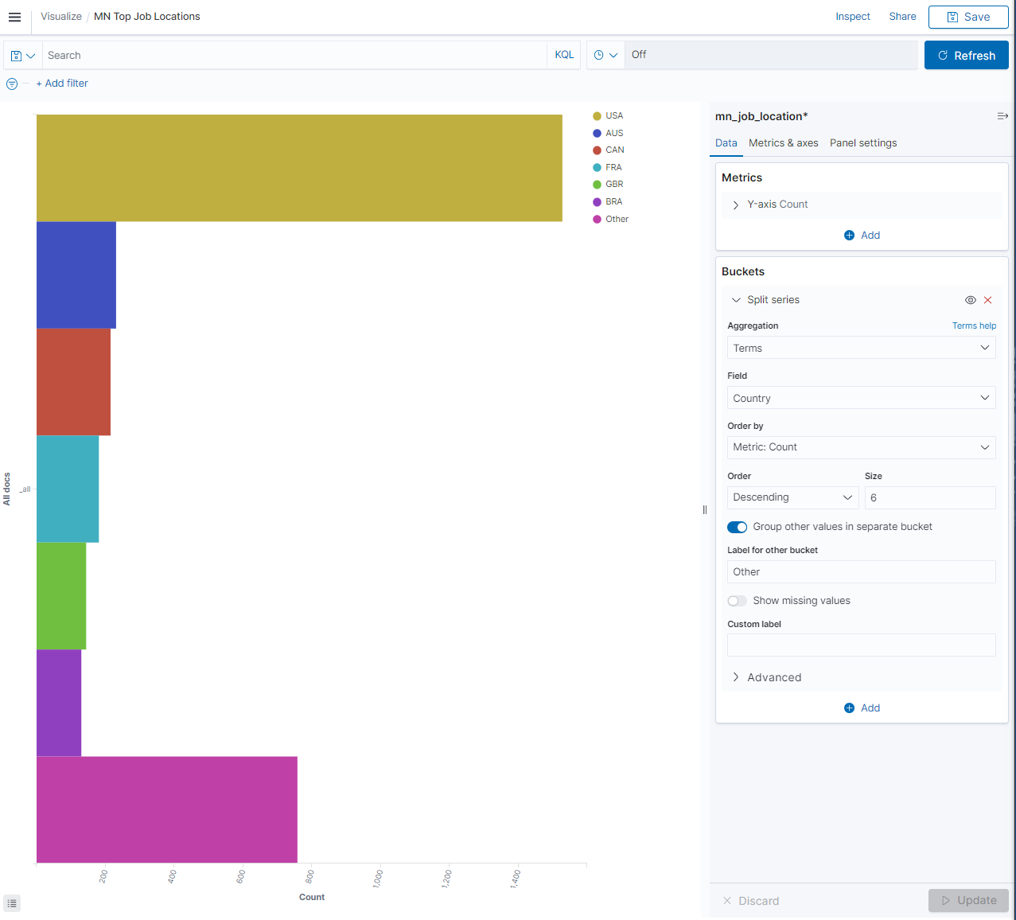

I saved the visualisation as ‘MN Top Job Locations’

**Important!** the *Time Period* up top. You may need to play with this to see your data!



### Visualisation Example 2

As before I created a new visualisation, using the mn_job_location index pattern. This time I opted to use the Region Map.

Our data contains the three letter country codes, so in the ‘Options’ tab I’ve updated the ‘join field’:

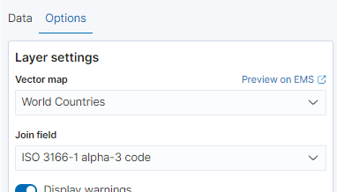

And added a Bucket:

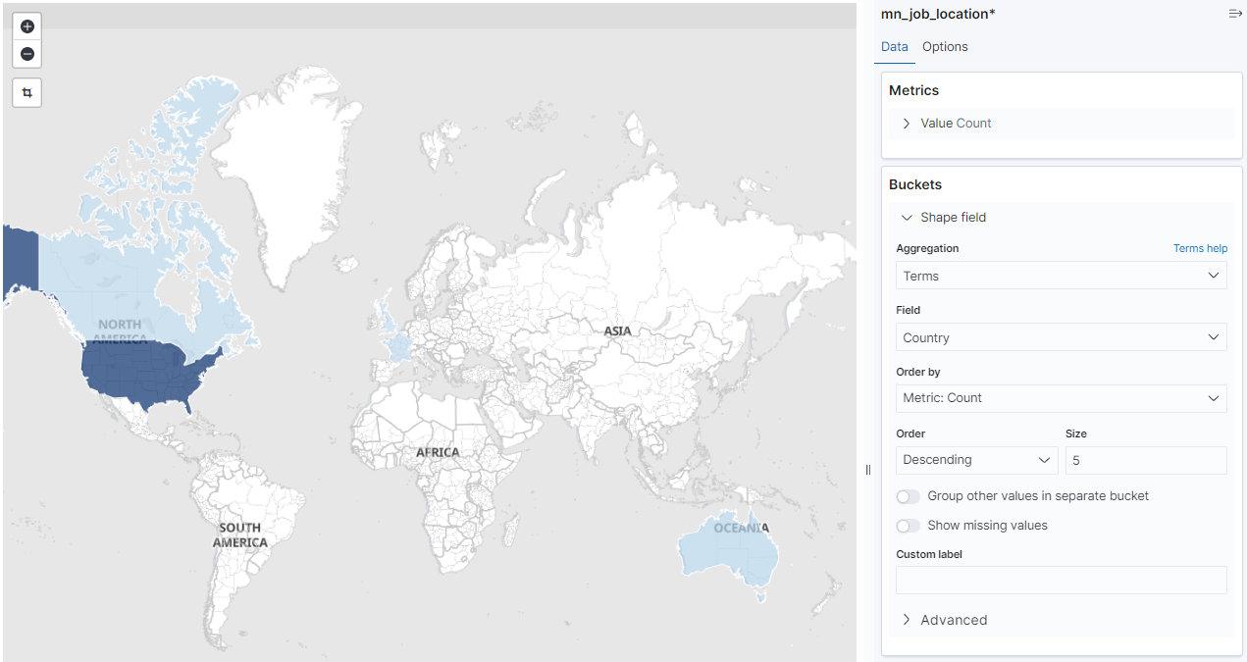

I’ve saved this visualisation as ‘MN Top Job Locations Map’

### Visualisation Example 3

As before I created a new visualisation, using the mn_job_location index pattern. This time I opted to use the Tag Cloud.

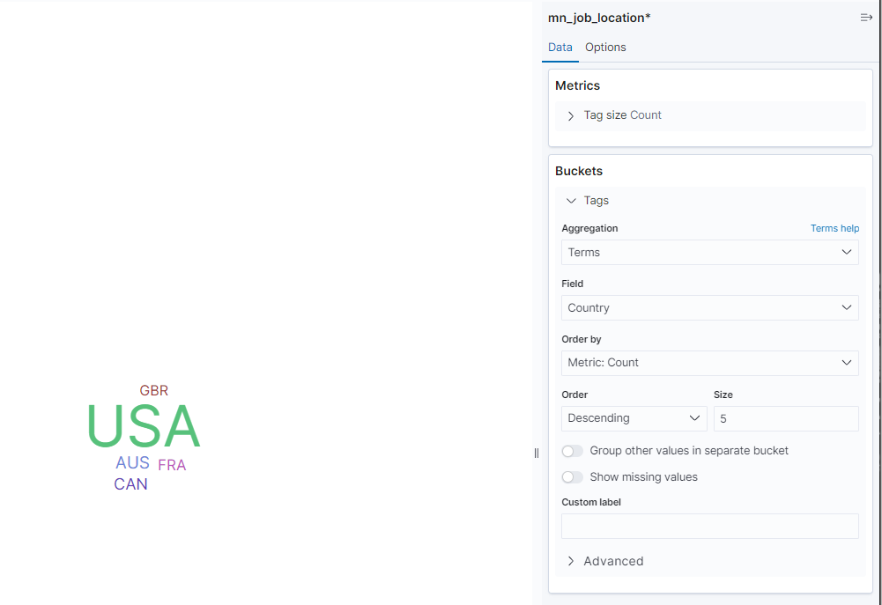

I’ve saved this visualisation as ‘MN Top Job Locations Cloud’

## Dashboard

*Kibana > Dashboard*

Now we will make a Kibana Dashboard form the 3 example visualisations.

Click ‘Create’ and then ‘Add an existing’ to add our three visualisations as panels:

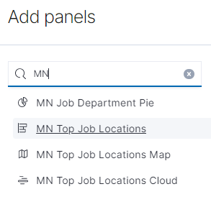

Our completed Dashboard:

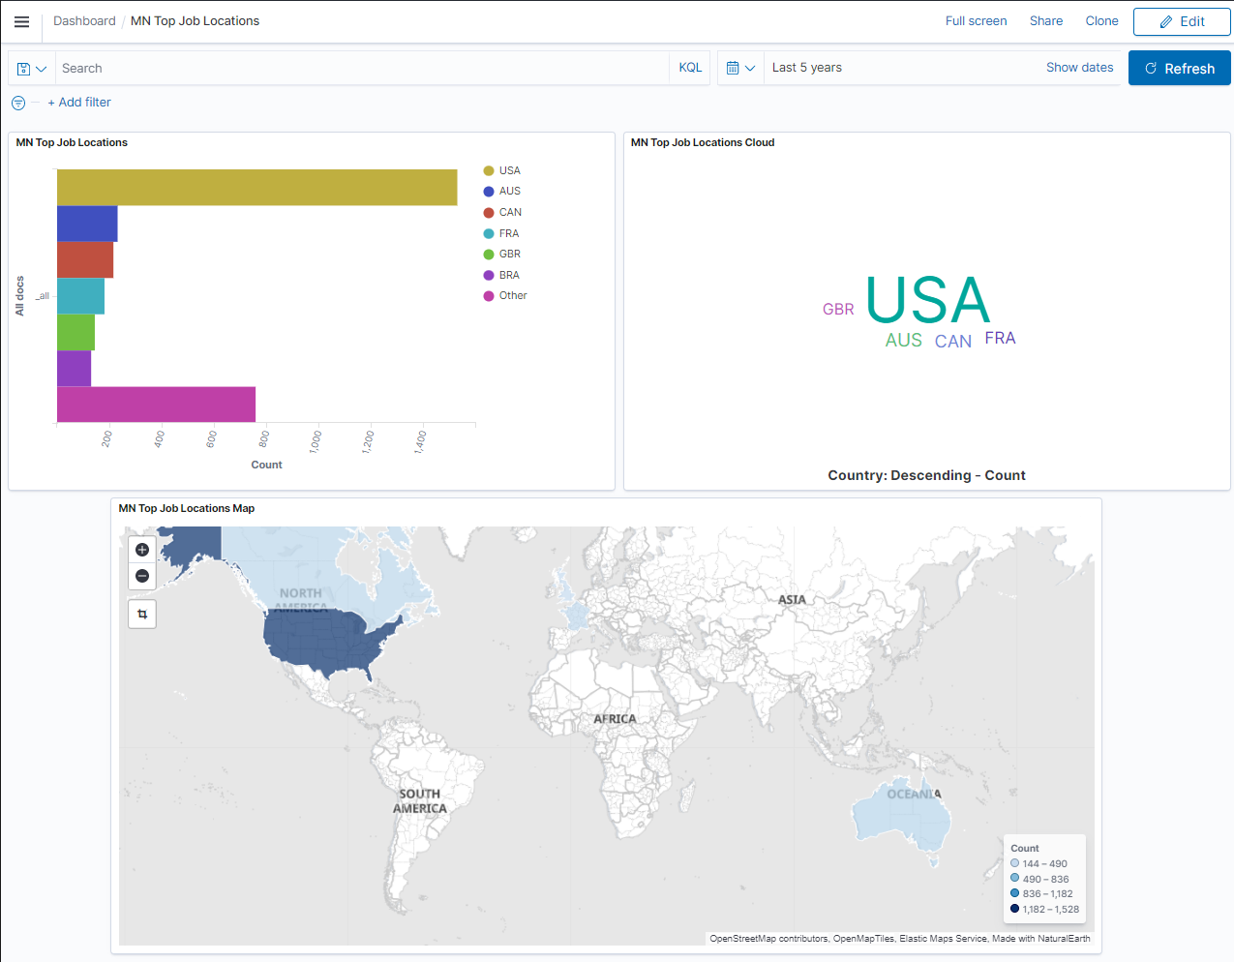

## Filters

Each visualisation, and each Dashboard, has filters up the top. When applied to a Dashboard it affects every visualisation in the Dashboard.

**Note**: I suspect it is best practise for each visualisation in a dashboard to be using the same Index Pattern. This way the filters will affect each exactly the same way, and they will all be in sync. There may be clever exceptions to this idea.

Example:

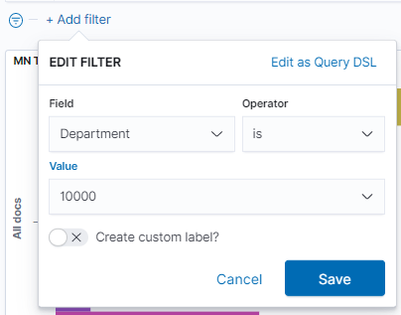

Result:

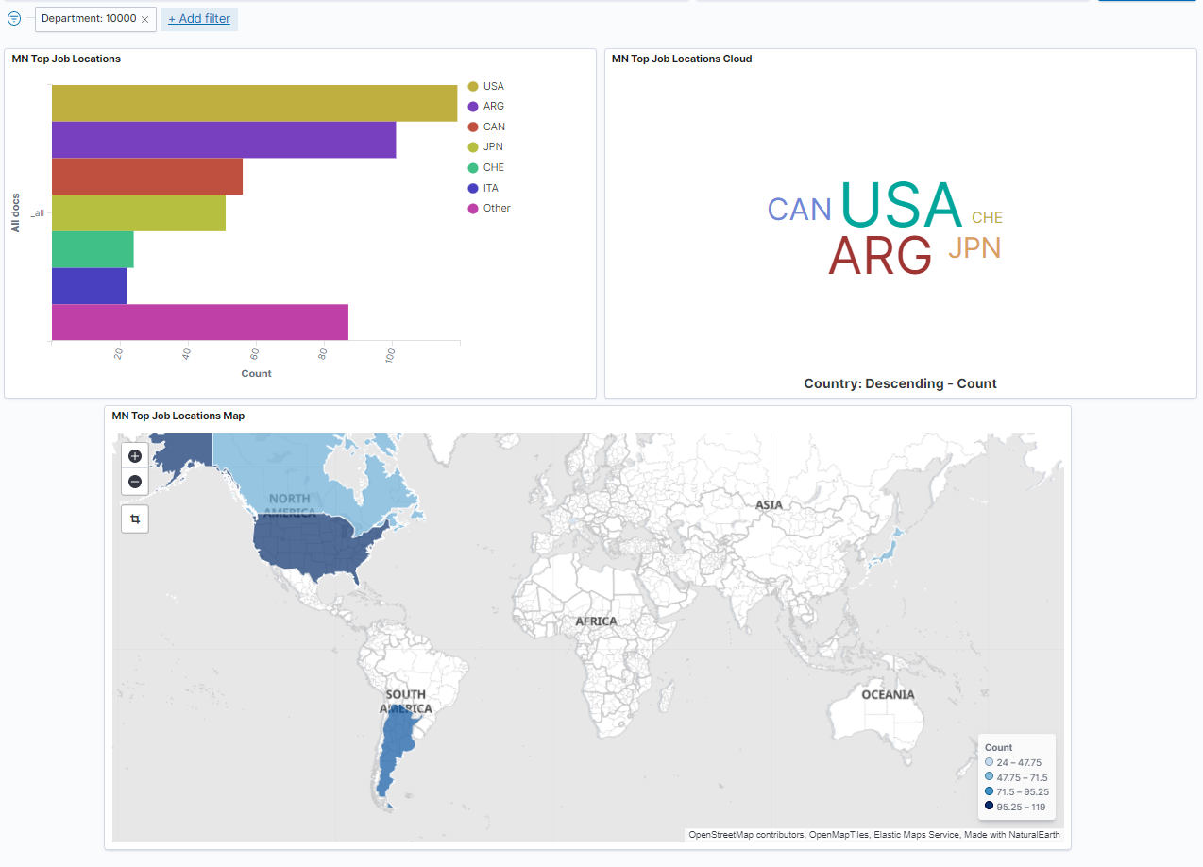

For Department 1000 the countries, the data, has changed, and now Argentina is #2.

# PeopleSoft Kibana Dashboards

Finally, we can import our Kibana dashboard into PeopleSoft, as tiles, related content etc.

## Import Kibana Dashboard

*PeopleTools > Search Framework > Administration > Import Dashboards from Kibana*

Add a new row, add your dashboard, click ‘Import’, and save. Simples.

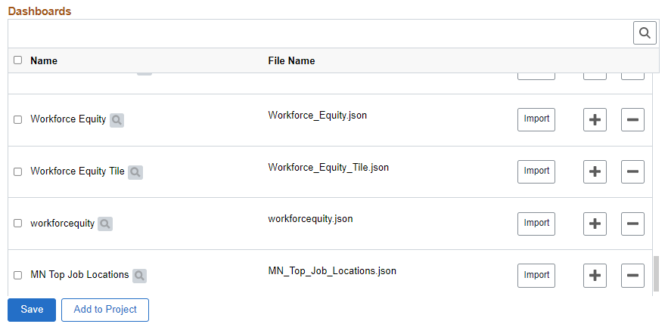

## Configure Kibana Dashboards

This component configures an imported Kibana dashboard as a Tile. Neat!

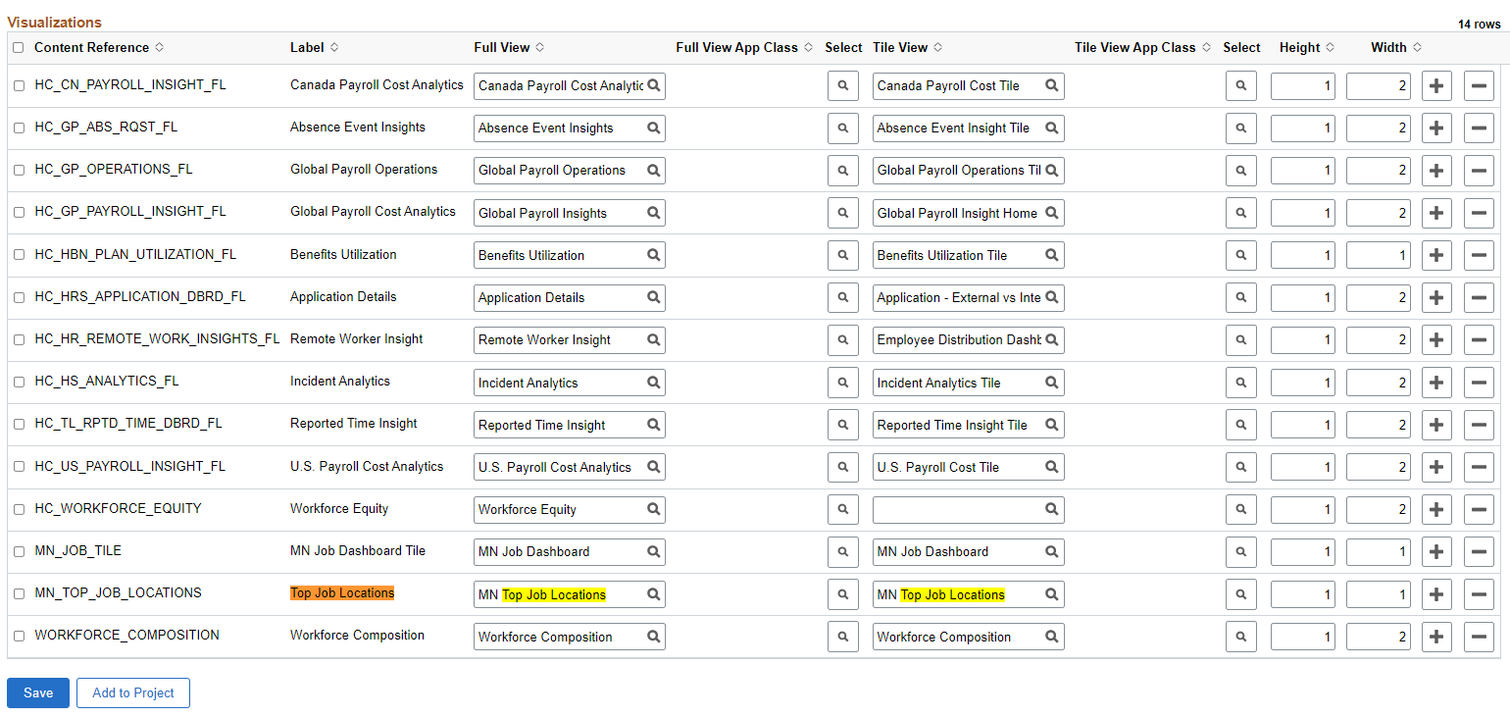

You can find this in *PeopleTools > Portal > Portal Structure*  
Under *Root > Fluid Structure Content > Fluid Pages > PeopleSoft Applications*

## Deploy Kibana Dashboards

*PeopleTools > Search Framework > Administration > Deploy Dashboards to Kibana*

Select your dashboard, and then click the ‘Deploy’ button at bottom of the list.

Easy.

## Add Tile to Homepage

On any HomePage > select ‘Personalize Homepage’ in the hamburger menu up top:

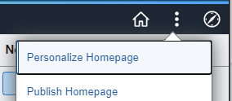

Then ‘Add Tile’



Search for your Dashboard Tile:

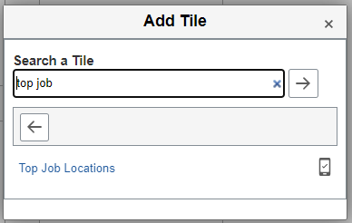

Arrange it if you want:

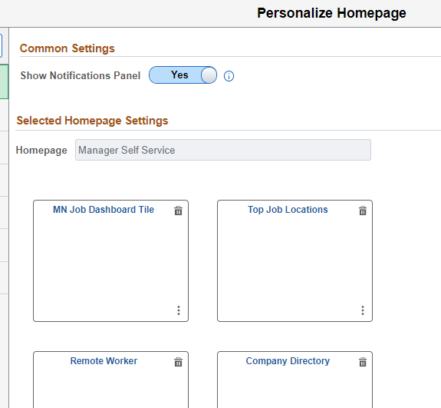

Save; Done!

# Final Result

Your homepage now has a new, Kibana Dashboard Tile for ‘Top Job Locations’:

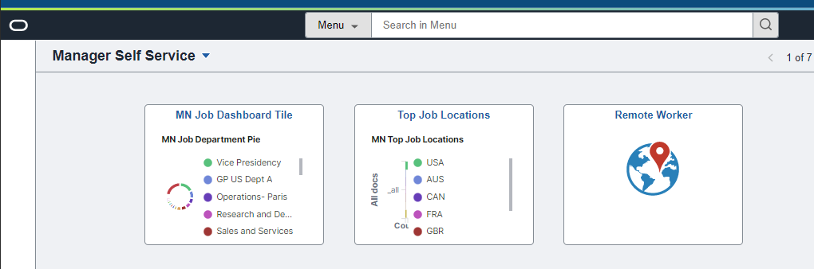

When opened:

